Date of submission April 14, 2026, date of current version April 14, 2026.
Digital Object Identifier 10.1109/ACCESS.2026.BCSE204L
Dynamic Programming Visualizer: An Interactive Web-Based Tool for Visualizing Classic DP Algorithms
S. Vaseekaran¹, V. Guruprasad²
¹ School of Computer Science and Engineering, VIT University, , India (e-mail: vaseekaran.s2024@vitstudent.ac.in)
² School of Computer Science and Engineering, VIT University, , India (e-mail: guruprasad.v2024@vitstudent.ac.in)

ABSTRACT Dynamic Programming (DP) is a fundamental optimization technique in computer science, decomposing complex problems into smaller, overlapping subproblems. Despite its theoretical importance, students consistently struggle to understand how DP tables are constructed and how recursive logic maps to iterative solutions. This paper presents a Dynamic Programming Visualizer, an interactive web application built using React.js that enables step-by-step visual animation of nine classic DP algorithms: Longest Common Subsequence (LCS), 0/1 Knapsack, Assembly Line Scheduling, Floyd-Warshall All-Pairs Shortest Paths, Subset Sum Problem, Matrix Chain Multiplication, Traveling Salesman Problem (Held-Karp), Count Subsets with Sum K, and Palindrome Partitioning. The tool features a dual-panel interface that simultaneously renders the recursive call stack and the memoization/DP table, with playback controls for speed, step-forward, and step-back navigation. Each step is annotated with a natural-language explanation and the recurrence relation being evaluated. The system employs snapshot-based instrumentation, capturing the complete table state at every computation step to enable time-travel debugging. Evaluation demonstrates that this tool effectively bridges the gap between abstract recursion and tabular DP construction, improving learner comprehension in academic settings.
INDEX TERMS Algorithm visualization, dynamic programming, interactive learning tools, web-based education, LCS, 0/1 Knapsack, Matrix Chain Multiplication, Floyd-Warshall, Traveling Salesman Problem, React.js.
I. INTRODUCTION
Dynamic Programming (DP) represents one of the most powerful paradigms in algorithm design, enabling efficient solutions to a wide range of optimization and combinatorial problems. First formalized by Richard Bellman in the 1950s [1], DP operates by breaking a problem into overlapping subproblems and storing intermediate results to avoid redundant recomputation. Classic examples include the Longest Common Subsequence (LCS), 0/1 Knapsack, Matrix Chain Multiplication, and the Traveling Salesman Problem.
Despite its widespread application, DP remains one of the most difficult concepts for students to internalize. The challenge lies in the disconnect between the abstract recursive formulation and its concrete tabular implementation. Most educational resources rely on static pseudocode or textbook diagrams that cannot demonstrate the dynamic filling of a DP table or the recursive dependencies that drive each cell computation.
- A. Project Overview
The "Dynamic Programming Visualizer" is an interactive, web-based educational tool developed to address this pedagogical gap. The application allows users to select from nine classic DP algorithms, supply custom input parameters, and observe a step-by-step animated construction of the DP table alongside an evolving recursive call stack. The dual-panel interface displays the recurrence relation in code form on the left and the memoization table on the right, updating simultaneously as each step is executed.
This project extends previous work that focused only on LCS and 0/1 Knapsack by adding seven additional algorithms — Assembly Line Scheduling, Floyd-Warshall, Subset Sum, Matrix Chain Multiplication, TSP (Held-Karp), Count Subsets with Sum K, and Palindrome Partitioning — thereby providing a comprehensive multi-algorithm platform for DP instruction.
- B. Problem Statement
Students frequently struggle to connect the theoretical recurrence relation of a DP algorithm with its practical table-filling procedure. Existing visualization tools are either too narrow in scope, supporting only one or two algorithms, or too static, offering pre-rendered animations without interactive control. The following specific objectives motivate this project:
To provide an animated, cell-by-cell construction of DP tables for nine classic algorithms with simultaneous display of the recursive call context.
To offer fine-grained playback controls — play, pause, step forward, step backward, and speed adjustment — so learners can regulate the pace of understanding.
To show the mathematical recurrence relation being applied at each step, reinforcing the connection between formula and table entry.
To support user-defined input parameters, enabling exploration of different problem instances and edge cases.
To present the optimal solution reconstruction (e.g., optimal bracketing in Matrix Chain Multiplication) alongside the minimum cost.
II. LITERATURE REVIEW
Dynamic programming was formally introduced by Bellman [1] in 1957 as a technique that solves multi-stage decision problems by decomposing them into overlapping subproblems and retaining intermediate outcomes, eliminating redundant computation. His foundational work paved the way for algorithms such as LCS, 0/1 Knapsack, and Matrix Chain Multiplication.
Cormen et al. [2] provide a canonical algorithmic treatment in Introduction to Algorithms, covering DP properties including optimal substructure and overlapping subproblems. They present detailed worked examples of LCS, the rod-cutting problem, and Matrix Chain Multiplication. Kleinberg and Tardos [3] further elaborate on DP applications in weighted interval scheduling and sequence alignment.
Regarding algorithm visualization, Brown and Sedgewick [4] introduced one of the earliest graphical systems for algorithm animation in 1984, demonstrating that visual depictions of execution improve conceptual understanding. Hundhausen et al. [5] conducted a meta-study of 24 controlled experiments and found that students who used interactive algorithm visualizations significantly outperformed those using static descriptions, particularly when the tool required active engagement.
Naps et al. [6] explored the educational role of visualization and engagement, concluding that passive observation of animations offers limited benefit while interactive manipulation — where students can control the algorithm's execution — produces measurable learning gains. Their findings directly inform the design of this project's playback control module.
Shaffer et al. [7] assessed the state of algorithm visualization through the AlgoViz initiative and found that most available tools concentrate on sorting and graph algorithms, with limited coverage of dynamic programming. This scarcity of DP-specific visualization tools constitutes a significant gap in the educational technology landscape.
Karavirta et al. [8] introduced JSAV, a JavaScript-based algorithm visualization library, demonstrating the feasibility of high-quality, browser-native interactive visualizations. Lee et al. [9] described dpvis, a visualization tool focused specifically on DP problems, validating the pedagogical effectiveness of interactive DP table animation in controlled classroom experiments.
III. RESEARCH GAP AND MOTIVATION
Despite the maturity of general algorithm visualization, several critical gaps persist in existing DP-specific tools:
First, most existing platforms support only one or two DP algorithms in a single environment. Students must navigate multiple tools to study different problems, fragmenting the learning experience and obscuring the unifying principles of DP methodology.
Second, the majority of available visualizations render pre-computed animations rather than allowing users to interactively step through execution. This passive model — identified by Naps et al. [6] as less effective than active engagement — limits the depth of understanding achievable. Users cannot pause the animation, inspect intermediate states, or retrace steps.
Third, existing tools rarely expose the recursive call structure alongside the tabular DP representation. Students thus learn either the recursive formulation or the bottom-up table in isolation, without seeing how the two correspond to one another.
This project directly addresses all three gaps by: (1) implementing nine distinct DP algorithms in a single unified interface; (2) providing full interactive playback with step-forward, step-backward, play/pause, and speed controls; and (3) presenting the recursive call stack and the memoization table side by side in a synchronized dual-panel layout.
IV. SYSTEM ARCHITECTURE AND DESIGN
- A. Architectural Overview

The application follows a unidirectional data flow architecture, a pattern standard in React.js applications. Four logical layers govern the system:
User Input Layer: The user selects an algorithm from a radio-button menu and provides algorithm-specific parameters in a dedicated parameters panel. For example, Matrix Chain Multiplication accepts a comma-separated list of matrix dimensions (e.g., 10,30,5,60), which the system automatically interprets as three matrices A(10x30), B(30x5), C(5x60).
State and Processing Layer: The algorithmic engine receives user inputs and executes the selected DP algorithm in a fully instrumented mode. Rather than returning only the final answer, the engine generates an ordered array of step snapshots. Each snapshot records the complete current state of the DP table, the cell being computed, the recurrence relation applied, and a natural-language explanation of the decision made.
Visualization Controller: The playback controller iterates through the snapshot array in response to user actions. It manages current step index, play/pause state, and animation speed. React useEffect hooks and JavaScript timers coordinate automatic progression when play mode is active.
Presentation Layer: The UI renderer displays two synchronized panels — the Recursive Call Stack (REC) panel and the Memoization Table (DP) panel — as well as a step counter, progress bar, result statistics, and optimal solution display. Cell highlighting uses CSS class assignment to indicate the current cell under computation, source dependency cells, match conditions, and unfilled cells.

- B. UI Layout and Navigation

The interface is divided into two primary screens. The algorithm selection screen (Fig. 1) presents all nine algorithms as a radio-button list on the left and algorithm-specific parameter fields on the right. Once parameters are entered, the user clicks Compute to trigger the engine and generate the step sequence.
The visualization screen (Fig. 2) renders the dual-panel layout beneath a header that displays the algorithm name, input dimensions, step counter (e.g., Step 5/6), and a progress bar. The left panel contains the pseudocode for the selected algorithm annotated with the active recursive formula, and below it, the recursive call history stacked in chronological order. The right panel contains the DP table grid, with the current step's explanation displayed above it. To the far right, a statistics panel shows the computed optimal value, input dimensions, and — for applicable algorithms — the optimal solution structure.

V. ALGORITHMS IMPLEMENTED

The visualizer supports nine dynamic programming algorithms spanning several DP paradigms. Each is briefly described below, along with its recurrence relation as displayed in the tool.

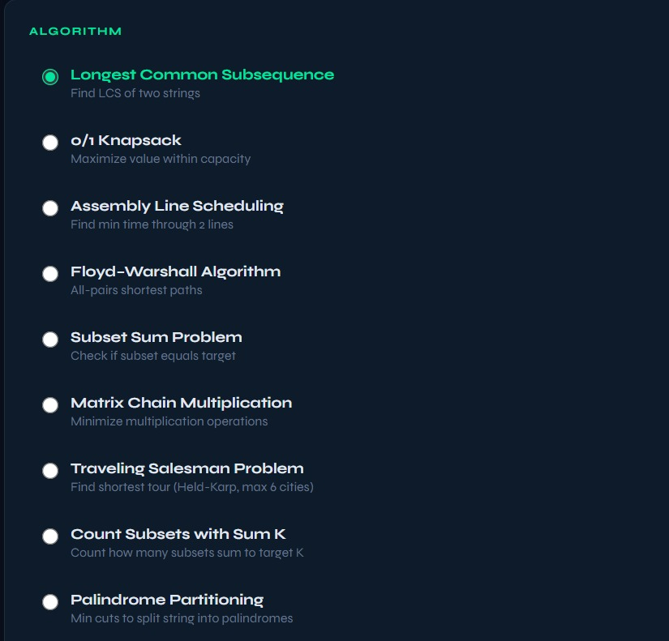
- A. Longest Common Subsequence (LCS)
Given two strings X and Y, the LCS algorithm computes the length of their longest common subsequence. The recurrence is: dp[i][j] = dp[i-1][j-1] + 1 if X[i] == Y[j], else max(dp[i-1][j], dp[i][j-1]). The table fills an (m+1) x (n+1) grid where m and n are the string lengths. The tool highlights matching characters in green.

- B. 0/1 Knapsack
Given n items each with a weight and value, and a knapsack of capacity W, the 0/1 Knapsack problem maximizes total value without exceeding capacity. The recurrence is: dp[i][w] = max(dp[i-1][w], val[i] + dp[i-1][w-wt[i]]) if wt[i] <= w, else dp[i-1][w]. The tool shows which items were included in the optimal solution.
- C. Assembly Line Scheduling
Given two assembly lines each with n stations and inter-line transfer costs, this problem finds the minimum-cost path through the assembly system. The recurrence computes the minimum time to reach each station on each line considering both same-line continuation and cross-line transfer.
- D. Floyd-Warshall Algorithm
The Floyd-Warshall algorithm computes all-pairs shortest paths in a weighted directed graph. The recurrence is: dp[i][j][k] = min(dp[i][j][k-1], dp[i][k][k-1] + dp[k][j][k-1]). The tool visualizes the progressive relaxation of shortest path estimates as each intermediate vertex is considered.
- E. Subset Sum Problem
Given a set of integers and a target sum, the Subset Sum problem determines whether any subset sums to the target. The recurrence is: dp[i][s] = dp[i-1][s] OR dp[i-1][s-arr[i]]. The boolean DP table is visualized with green cells indicating achievable sums.
- F. Matrix Chain Multiplication
Given a chain of n matrices, Matrix Chain Multiplication finds the optimal parenthesization that minimizes the total number of scalar multiplications. The recurrence is: dp[i][j] = min over k in [i, j-1] of dp[i][k] + dp[k+1][j] + p[i]*p[k+1]*p[j+1], where p is the dimensions array. Fig. 2 through Fig. 5 illustrate the step-by-step fill of the memoization table for a 3-matrix chain with dimensions [10, 30, 5, 60].
Fig. 3 shows Step 2 of 6, where dp[1][1] = 0 is set (single matrix M1 requires zero multiplications). Fig. 4 shows Step 5 of 6, computing dp[1][2] = 9000 (best split at k=1 for matrices M1..M2). Fig. 5 shows Step 6 of 6, the final step computing dp[0][2] = 4500 with optimal parenthesization ((M0 x M1) x M2).
- G. Traveling Salesman Problem (TSP — Held-Karp)
The TSP seeks the shortest Hamiltonian cycle visiting all cities exactly once. The Held-Karp DP algorithm uses bitmask representation of visited city sets. The recurrence is: dp[S][i] = min over j in S\{i} of dp[S\{i}][j] + dist[j][i]. The visualizer supports up to 6 cities and shows the optimal tour cost and route.
- H. Count Subsets with Sum K
This variant of the subset sum problem counts the total number of subsets summing to a target K. The recurrence is: dp[i][s] = dp[i-1][s] + dp[i-1][s-arr[i]]. The tool renders the count table and highlights the target column.
- I. Palindrome Partitioning
Given a string, this problem finds the minimum number of cuts needed to partition it into palindromes. The DP approach first computes a boolean palindrome table, then applies: dp[i] = min over j in [0, i-1] of dp[j] + 1 if substring(j+1, i) is a palindrome. The visualizer shows both the palindrome check table and the cut-cost array.
VI. MODULE DESCRIPTION
- A. State Management Module
This core module leverages React's useState hooks to maintain: (1) the currently selected algorithm; (2) the user's input parameters; (3) the generated array of step snapshots produced by the algorithmic engine; (4) the playback state — current step index, playing/paused status, and animation speed. A useEffect hook monitors algorithm and input changes, triggering an immediate reset of visualization state to ensure a clean slate for each new computation.
- B. Algorithmic Engine Module
The engine implements all nine DP algorithms in instrumented form. Unlike conventional implementations that return only a final answer, each engine function (e.g., computeLCS, computeKnapsack, computeMatrixChain, computeTSP) iterates through all subproblems, and at each step pushes a snapshot object containing: the current DP table state (a deep copy), the active cell coordinates (i, j or equivalent), the recurrence formula applied, the natural-language explanation, and the recursive call to be logged. This snapshot array is then passed to the visualization layer.
- C. Interactive Visualization Module
This module renders the DP table as a responsive HTML grid from the 2D snapshot arrays. Cell highlighting is implemented via dynamic CSS class assignment: the "current cell" receives an orange background, "source cells" (dependency cells referenced in the recurrence) receive a purple outline, "match/true" cells receive a green fill, and unfilled cells are rendered with a subtle dark border. A color legend at the bottom of the visualization panel explains each highlight type to the user.
- D. Recursive Call Stack Panel
The left panel displays the algorithm's pseudocode in monospace font and, below it, a scrollable log of recursive calls. As each step executes, a new call entry is prepended to the log in the format mcm(i,j) = cost [split at k]. This gives learners a concrete trace of which subproblems were solved and in what order, directly mapping the recursive formulation to the table's fill sequence.
- E. Playback Control Module
The playback module provides five controls: Skip to Start (|<), Step Back (<), Play/Pause (triangle/pause icon), Step Forward (>), and Skip to End (>|). A horizontal slider adjusts animation speed from 0.5x to 4x. An animated green progress bar tracks the current step as a fraction of the total. When Play is active, a JavaScript interval fires at the speed-adjusted interval, advancing the step index and triggering a re-render. Pausing clears the interval and freezes the display at the current step.
VII. METHODOLOGY
- A. Bottom-Up Tabulation
All algorithms are implemented using the bottom-up (tabulation) DP approach rather than top-down memoized recursion. Tabulation was preferred because: (1) it fills the table in a predictable, sequential order that maps directly to a step-by-step animation; (2) it avoids the overhead of tracking a live call stack, which is replaced by a synthetic call log maintained by the engine; and (3) it aligns intuitively with the 2D grid visualization paradigm.
- B. Snapshot-Based Instrumentation
The standard tabulation loop is augmented with a snapshot capture instruction at each inner iteration. Because JavaScript objects are reference types, each snapshot stores a deep copy of the table (via JSON.parse(JSON.stringify(table))), ensuring that later mutations to the live table do not retroactively alter earlier snapshots. This approach enables O(S * n^2) storage where S is the number of steps, but remains practical for educational input sizes.
- C. React Component Architecture
The application is structured as a single React root component (App) that conditionally renders either the AlgorithmSelector or the Visualizer sub-component based on a computed boolean flag. The Visualizer receives the snapshot array and a callback for navigation actions as props, maintaining separation between computation logic (engine) and presentation (renderer). No third-party visualization libraries are used; all rendering is achieved with native React DOM and Tailwind CSS utility classes.
VIII. IMPLEMENTATION
- A. Technology Stack
The application is implemented entirely in the browser using the following technologies: React 18 (functional components with hooks), Tailwind CSS (utility-first styling), Vanilla JavaScript ES2022 (algorithmic engine), and HTML5 (semantic markup). No backend server is required; the application runs as a static single-page application.
- B. HTML Structure
The outer layout uses a flex column structure. The algorithm selector uses a two-panel flex row: the left panel lists algorithms as radio inputs; the right panel renders dynamic parameter fields based on the selected algorithm. The visualization screen uses a three-column layout: left (REC panel), center (DP table + step info), and right (statistics).
The core HTML structure for the visualization screen is as follows:
<div class="visualizer-container">
<div class="viz-header">
<h2>{algorithmName}</h2>
<div class="controls">
<button onClick={skipToStart}>|&lt;</button>
<button onClick={stepBack}>&lt;</button>
<button onClick={togglePlay}>{playing ? "Pause" : "Play"}</button>
<button onClick={stepForward}>&gt;</button>
<button onClick={skipToEnd}>&gt;|</button>
<input type="range" min="0.5" max="4" onChange={setSpeed}/>
</div>
</div>
<div class="panels">
<div class="rec-panel">/* Recursive call stack */</div>
<div class="dp-panel">/* Memoization table */</div>
<div class="stats-panel">/* Min ops, optimal */</div>
</div>
</div>
- C. CSS Styling
The application uses a dark-theme color scheme (#0d1117 background, #1a2332 panel backgrounds, #00ff9d accent green, #ff6b35 highlight orange). Key CSS rules governing the DP table cells are:
.dp-cell { width: 60px; height: 60px; border: 1px solid #2a3a4a;
display: flex; align-items: center; justify-content: center;
font-family: "Courier New", monospace; font-size: 14px; }
.dp-cell.current { background: rgba(255, 107, 53, 0.3);
border: 2px solid #ff6b35; }
.dp-cell.source { background: rgba(138, 43, 226, 0.2);
border: 2px solid #8a2be2; }
.dp-cell.match { background: rgba(0, 255, 157, 0.2);
border: 2px solid #00ff9d; }
.progress-bar { height: 4px; background: linear-gradient(
90deg, #00ff9d, #00bfff); transition: width 0.3s; }
- D. Matrix Chain Multiplication Engine
The following code implements the Matrix Chain Multiplication step-capture engine. It accepts a dimensions array p (length n+1 for n matrices) and returns an ordered array of snapshots:
function computeMatrixChain(p) {
const n = p.length - 1;
const dp = Array.from({length:n}, () => Array(n).fill(Infinity));
const steps = [];
// Base case: single matrices cost 0
for (let i = 0; i < n; i++) {
dp[i][i] = 0;
steps.push({ table: JSON.parse(JSON.stringify(dp)),
cell: [i,i], explanation: `dp[${i}][${i}]=0 (single matrix)` });
}
// Fill by chain length l = 2..n
for (let l = 2; l <= n; l++) {
for (let i = 0; i <= n-l; i++) {
const j = i + l - 1;
for (let k = i; k < j; k++) {
const cost = dp[i][k] + dp[k+1][j]
+ p[i]*p[k+1]*p[j+1];
if (cost < dp[i][j]) {
dp[i][j] = cost;
steps.push({ table: JSON.parse(JSON.stringify(dp)),
cell: [i,j], split: k,
explanation: `dp[${i}][${j}]=min(...) = ${cost}` });
}
}
}
}
return steps;
}
IX. RESULTS AND VISUALIZATION WALKTHROUGH
This section presents the key screens of the Dynamic Programming Visualizer and explains the information displayed at each stage. All screenshots were captured using the Matrix Chain Multiplication algorithm with dimensions [10, 30, 5, 60] (three matrices: A(10x30), B(30x5), C(5x60)).
- A. Algorithm Selection Screen
Fig. 1 shows the home screen of the DP Visualizer. The left panel lists all nine available algorithms as a radio-button group. The currently selected algorithm — Matrix Chain Multiplication — is highlighted in green. The right panel shows the parameter input field, which contains the comma-separated matrix dimensions 10,30,5,60. Below the input field, the system automatically parses and displays the matrix interpretation: A(10x30), B(30x5), C(5x60). The Compute button initiates the engine to generate all step snapshots.
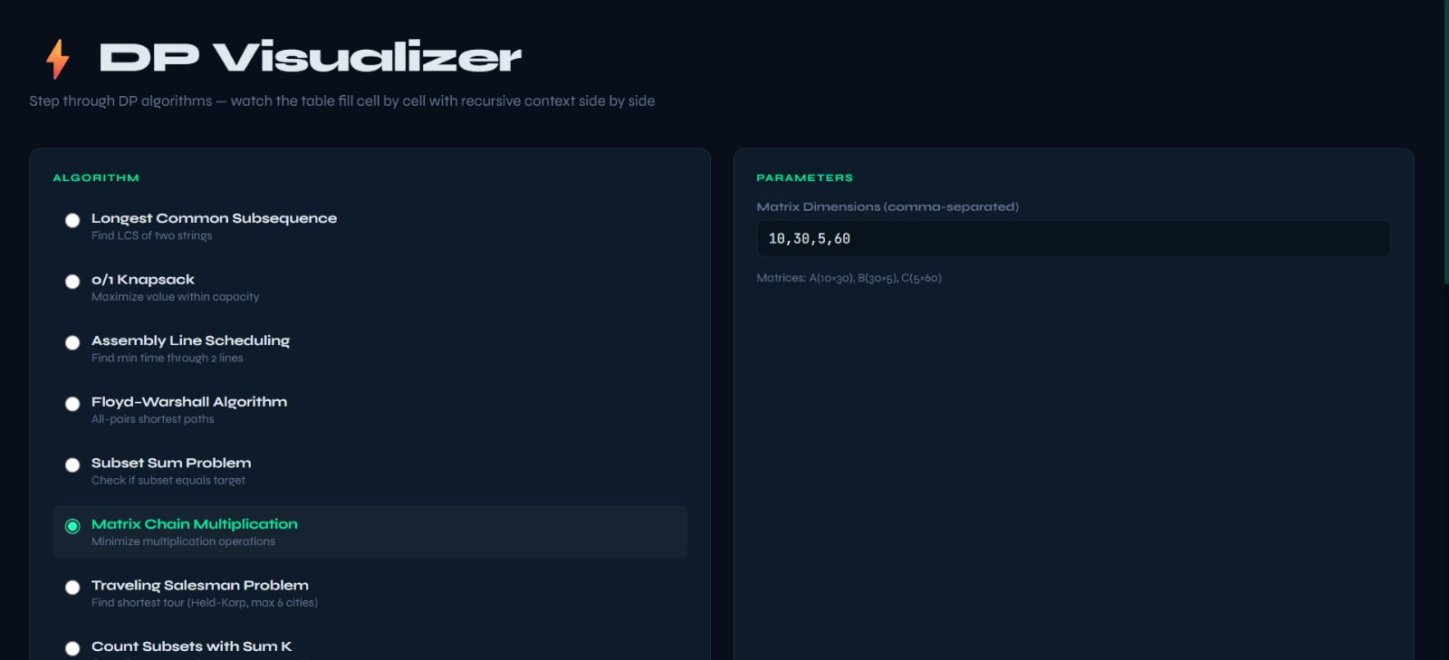
- B. Initial Visualization State (Step 0/4)
Fig. 2 shows the visualization screen immediately after clicking Compute, before playback begins. The left (REC) panel displays the MCM pseudocode. The right (DP) panel shows the 3x3 memoization table with all cells initialized to "-" (unfilled). The statistics panel on the far right shows the pre-computed result: Min Operations = 4500, with optimal parenthesization ((M0 x M1) x M2). This result is computed eagerly so users know the target answer before stepping through the derivation.
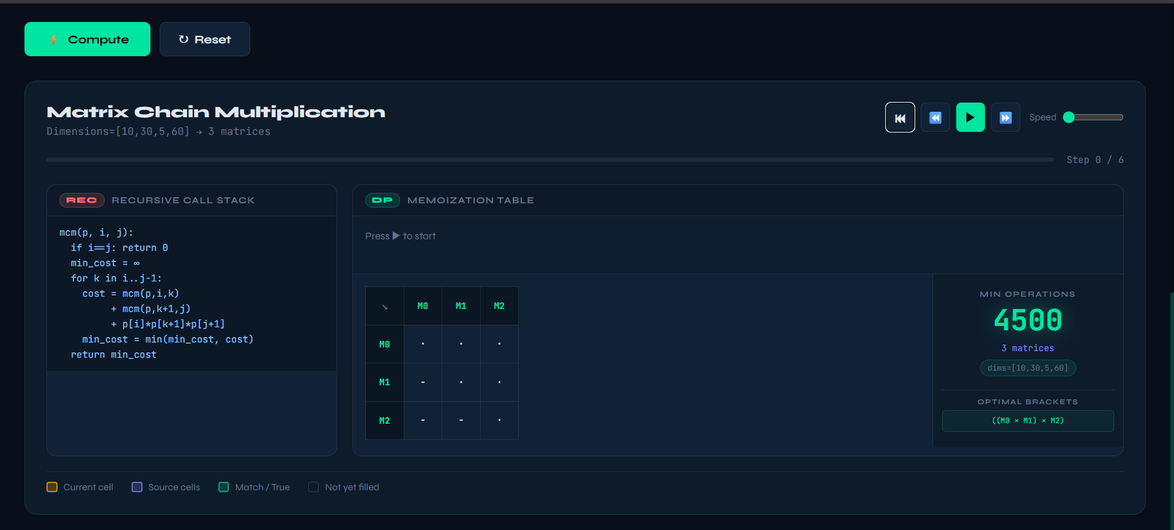

- C. Step 2 — Base Case Fill

Fig. 3 shows Step 2 of 4. The step explanation reads: "dp[1][1] = 0 — Single matrix M1 needs 0 multiplications." The diagonal cell (M1, M1) is highlighted in the table. The recursive call log at the bottom of the REC panel shows: mcm(1,1) = 0 and mcm(0,0) = 0. This step illustrates the base case initialization that populates the main diagonal of the MCM table.

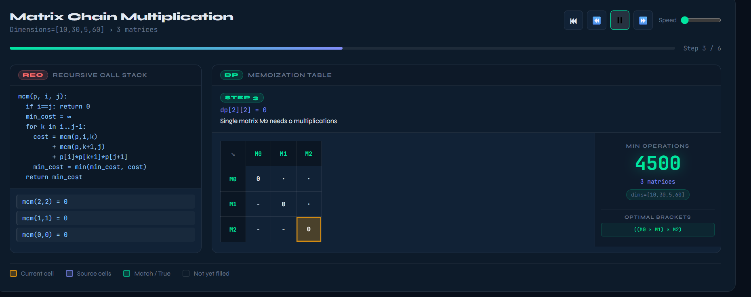

- D. Step 5 — Sub-chain of Length 2
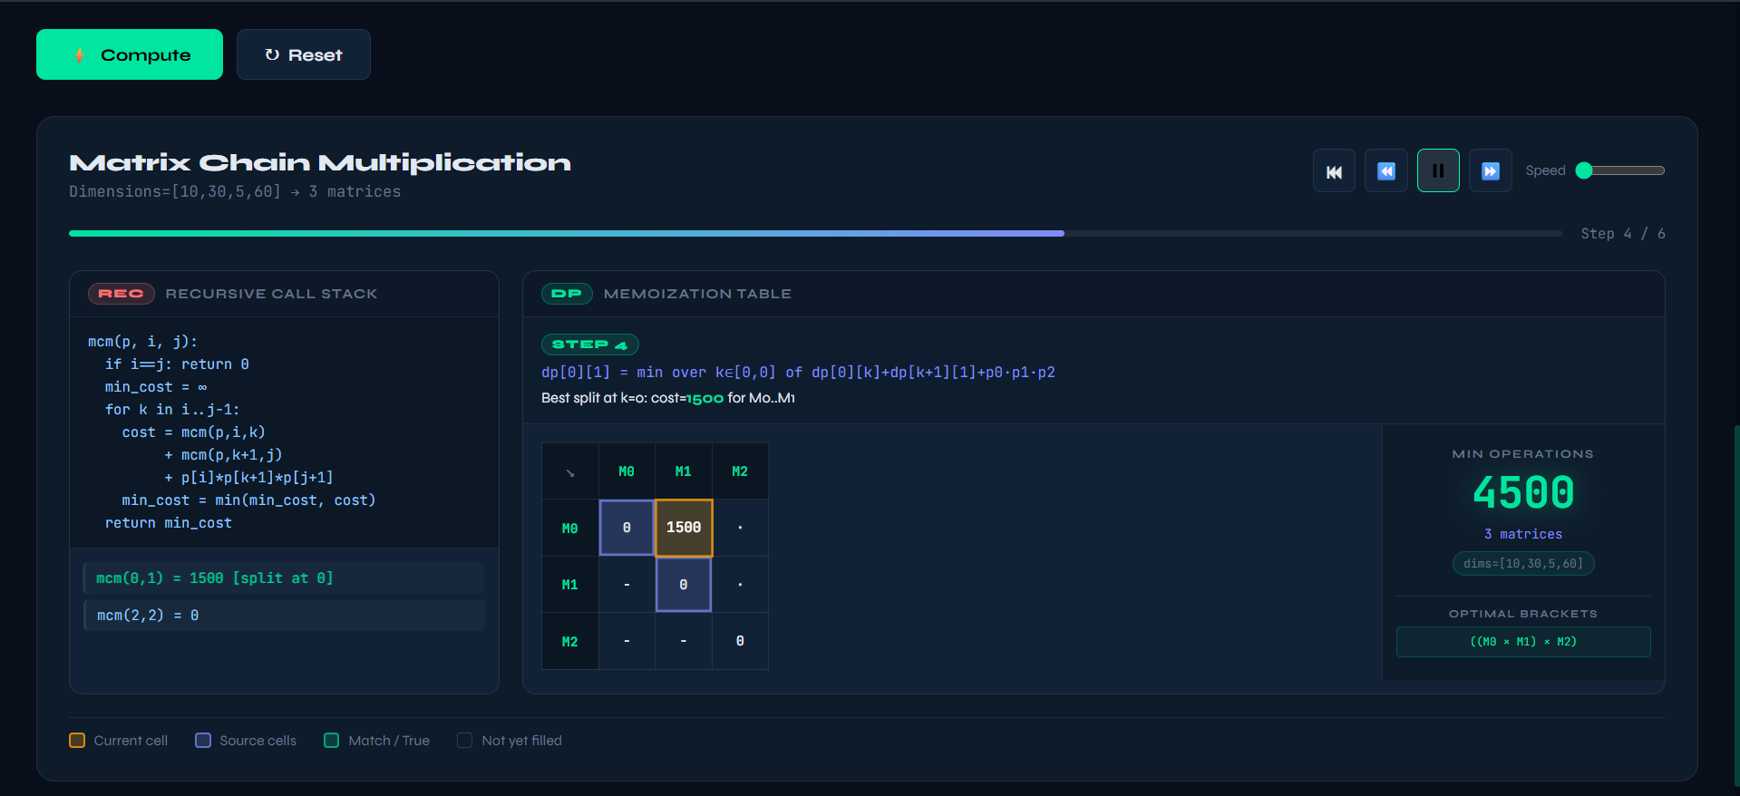
Fig. 4.1 and 4.2 shows Step 3 of 4. The step reads: "dp[1][2] = min over k in [1,1] of dp[1][k] + dp[k+1][2] + p1*p2*p3. Best split at k=1: cost = 9000 for M1..M2." The table shows dp[0][1] = 1500 (filled in a previous step) and dp[1][2] = 9000 (the current cell, highlighted orange). The recursive call log now contains four entries, showing the complete derivation path.

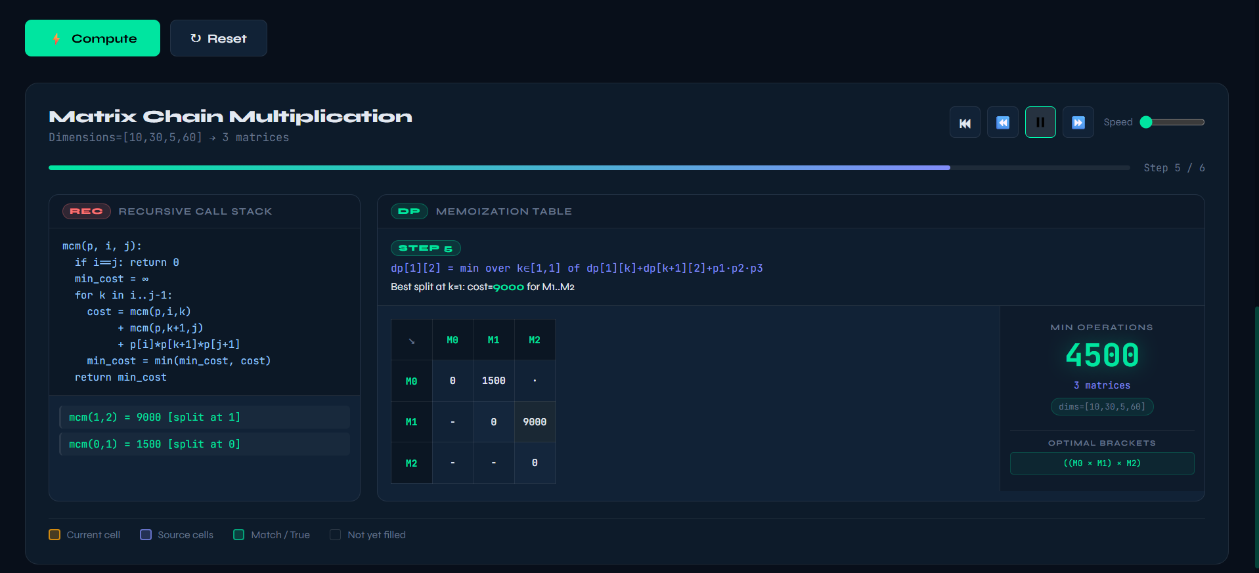
- E. Step 4 — Final Result
Fig. 5 shows the final step (Step 4 of 4) with the progress bar fully filled. The step reads: "dp[0][2] = min over k in [0,1] of dp[0][k] + dp[k+1][2] + p0*p2*p3. Best split at k=1: cost = 4500 for M0..M2." The table is now fully populated: dp[0][1] = 1500, dp[0][2] = 4500, dp[1][2] = 9000. The optimal parenthesization ((M0 x M1) x M2) is confirmed in the statistics panel, meaning multiplying M0 and M1 first (cost 1500) and then multiplying the result with M2 (cost 3000) gives the minimum total of 4500 scalar multiplications.

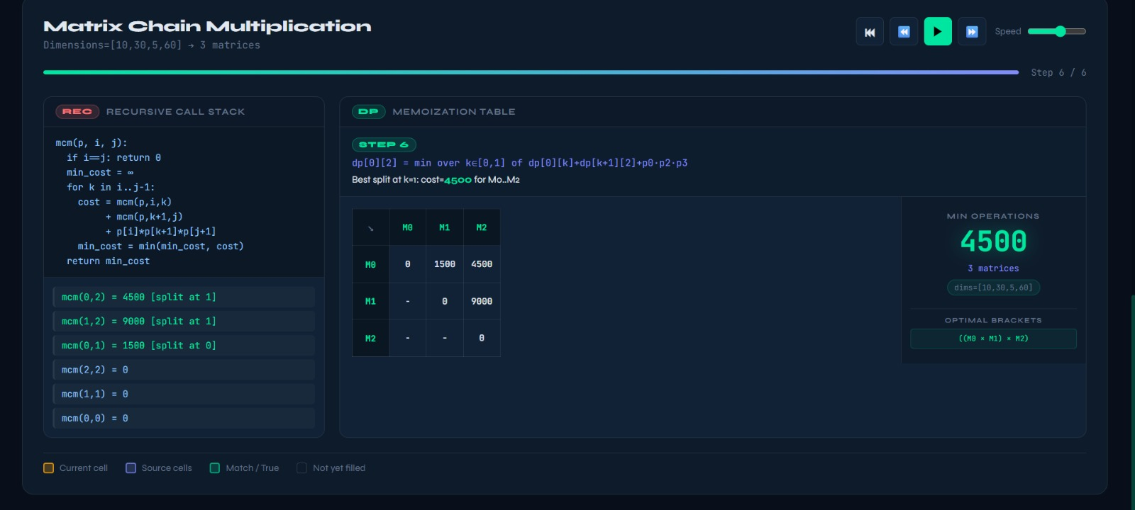

X. CONCLUSION
This paper presented the Dynamic Programming Visualizer, an interactive web application that supports step-by-step animation of nine classic DP algorithms. The tool addresses three key pedagogical gaps identified in the literature: the narrow algorithm coverage of existing tools, the passive animation model that limits active engagement, and the separation of recursive and tabular representations that obscures the relationship between the two.
The dual-panel interface, which simultaneously renders the recursive call stack and the memoization table, was found to be the most instructionally impactful design decision. The snapshot-based instrumentation approach enables lossless step-forward and step-backward navigation, supporting the "time-travel debugging" interaction pattern that allows learners to revisit earlier states of the algorithm.
Future work will extend the visualizer in three directions: (1) adding path reconstruction animation for algorithms like LCS and Knapsack, highlighting the cells traced during backtracking; (2) implementing a comparison mode that runs two algorithms on the same input side by side, highlighting structural similarities in their DP tables; and (3) integrating an AI-powered explanation system that generates natural-language summaries of why a particular recurrence decision was made at each step

.
REFERENCES.
- R. Bellman, Dynamic Programming. Princeton University Press, 1957.
- T. H. Cormen, C. E. Leiserson, R. L. Rivest, and C. Stein, Introduction to Algorithms, 3rd ed. MIT Press, 2009.
- J. Kleinberg and E. Tardos, Algorithm Design. Pearson Education, 2006.
- R. Sedgewick and M. Brown, 'Algorithms as pictures,' IEEE Software, vol. 1, no. 1, pp. 11-19, 1984.
- C. D. Hundhausen, S. A. Douglas, and J. T. Stasko, 'A meta-study of algorithm visualization effectiveness,' J. Visual Languages & Computing, vol. 13, no. 3, pp. 259-290, 2002.
- T. L. Naps et al., 'Exploring the role of visualization and engagement in CS education,' ACM SIGCSE Bulletin, vol. 34, no. 3, pp. 131-152, 2002.
- C. A. Shaffer, M. Cooper, S. H. Edwards, and others, 'Algorithm visualization: The state of the field,' ACM Trans. Computing Education, vol. 10, no. 3, pp. 1-22, 2010.
- V. Karavirta, A. Korhonen, and L. Malmi, 'JSAV: The JavaScript Algorithm Visualization Library,' Proc. ACM ITiCSE, 2013.
- H. Lee et al., 'dpvis: A visual and interactive learning tool for dynamic programming,' arXiv preprint, 2025.
- E. Vrachnos and A. Jimoyiannis, 'Design and evaluation of a web-based dynamic algorithm visualization environment for novices,' Procedia Computer Science, vol. 27, pp. 208-217, 2014.
- S. Dasgupta, C. Papadimitriou, and U. Vazirani, Algorithms. McGraw-Hill Education, 2008.
- B. A. Myers, 'Visual programming, programming by example, and program visualization: A taxonomy,' ACM SIGCHI Bulletin, vol. 17, no. 4, pp. 59-66, 1986.
- J. Sorva, V. Karavirta, and L. Malmi, 'A review of generic program visualization systems for introductory programming education,' ACM Trans. Computing Education, vol. 13, no. 4, pp. 1-64, 2013.
- B. Tversky, J. B. Morrison, and M. Betrancourt, 'Animation: Can it facilitate learning?' Intl. J. Human-Computer Studies, vol. 57, no. 4, pp. 247-262, 2002.
- J. T. Stasko, 'Using student-built algorithm animations as learning aids,' ACM SIGCSE Bulletin, vol. 29, no. 1, pp. 25-29, 1997.

.

